Англійська мова 8 клас з 05.05 по 29.05
05.05-Улюблені журнали.
Усно читати ,нові слова в словник,впр 8,ст 198 –усно.
06.05-Тести до Теми –Засоби масової інформації.
08.05-Світогляд.Вживання артикля THE.
Правила –див.параграф 2-3-4 ст.245.
Впр 1-2-ст.201 (усно),Впр.3-4(письмово),ст.201-202.
Д/З впр.5,ст.202.
12.05-Британські міста. Вживання артикля The.
Впр 1-3(А/В) –тести \письмово,ст.203-205
Впр 6,ст.206-усно.Д/З –тести
13.05-Що ще зроблено?
Теперішній перфектний час пасивного стану.-ст.208-209.
Впр 3(письмово),ст.209
Д/З-впр.7,ст.210.
15.05-Великобританія-географія та клімат.
Нові слова на ст.212-213 в словник .Читати текст впр 2в.
Д/З –тести.
19.05-Україна –географія та клімат.
Слова впр.4-ст.214-216 в словник.Текст чит впр.4в ст.215,впр 8ст.218-219 (читати).
Впр.5 письмово-ст.216. Д/З впр7,ст 216(письмово)
20.05-Видатні місця Англії.
Читати ст 220-224.Д/З впр 4-ст.225-226.
22.05-Видатні місця Англії.
Читати ст.229-232. Д/З тести. Контрольна робота з говоріння.
26.05-Контрольна робота з читання .
27.05-Контрольна робота з письма.
29.05-Контрольна робота з аудіювання.
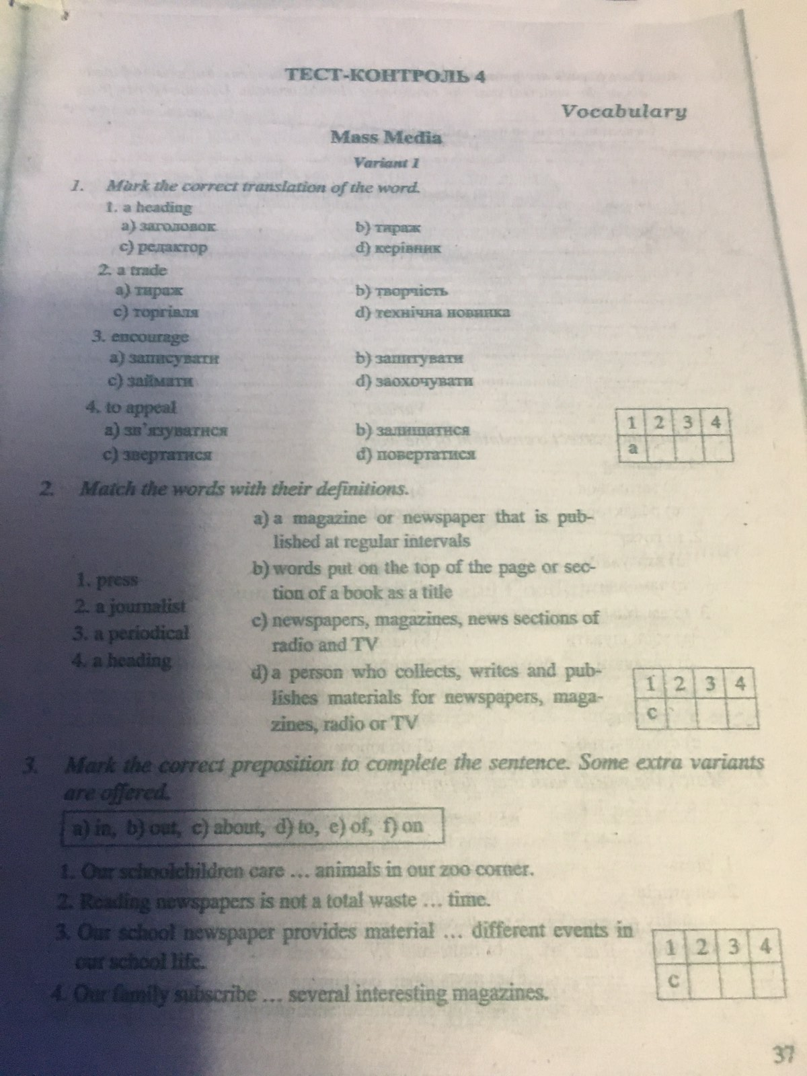

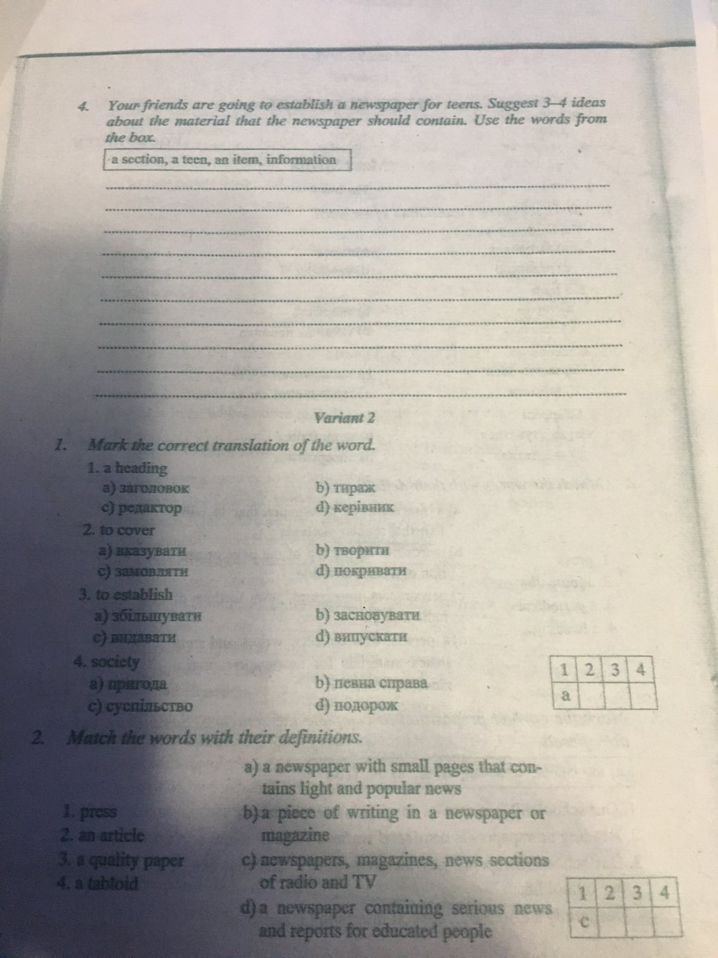
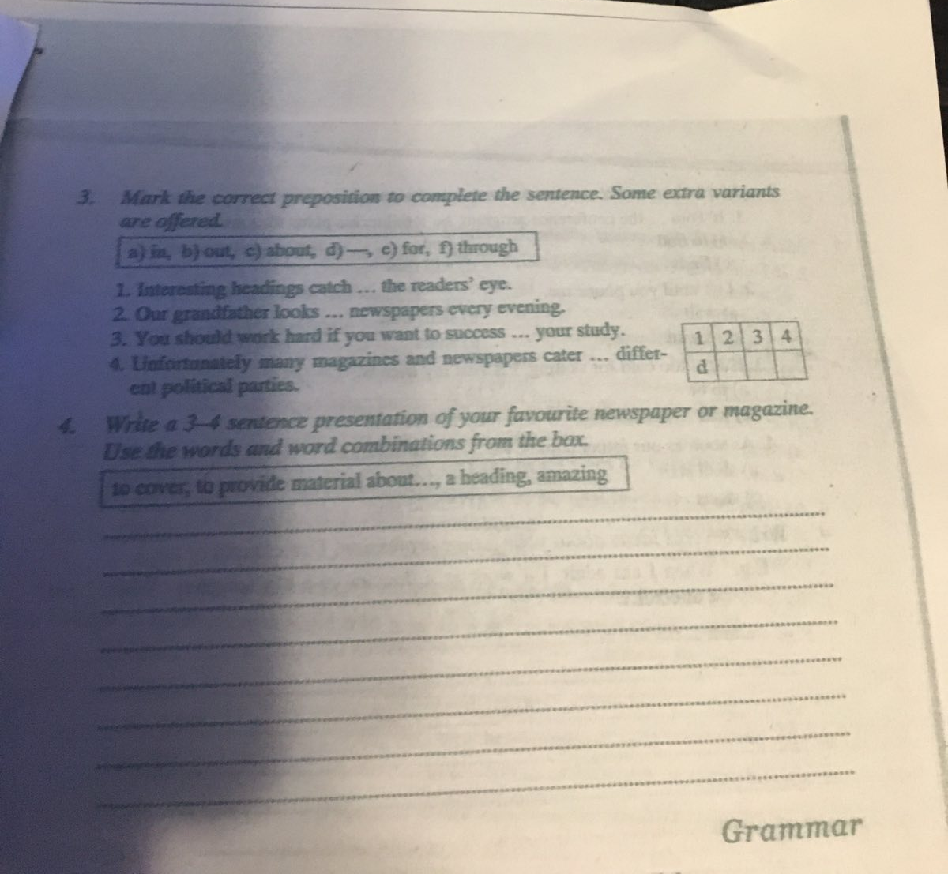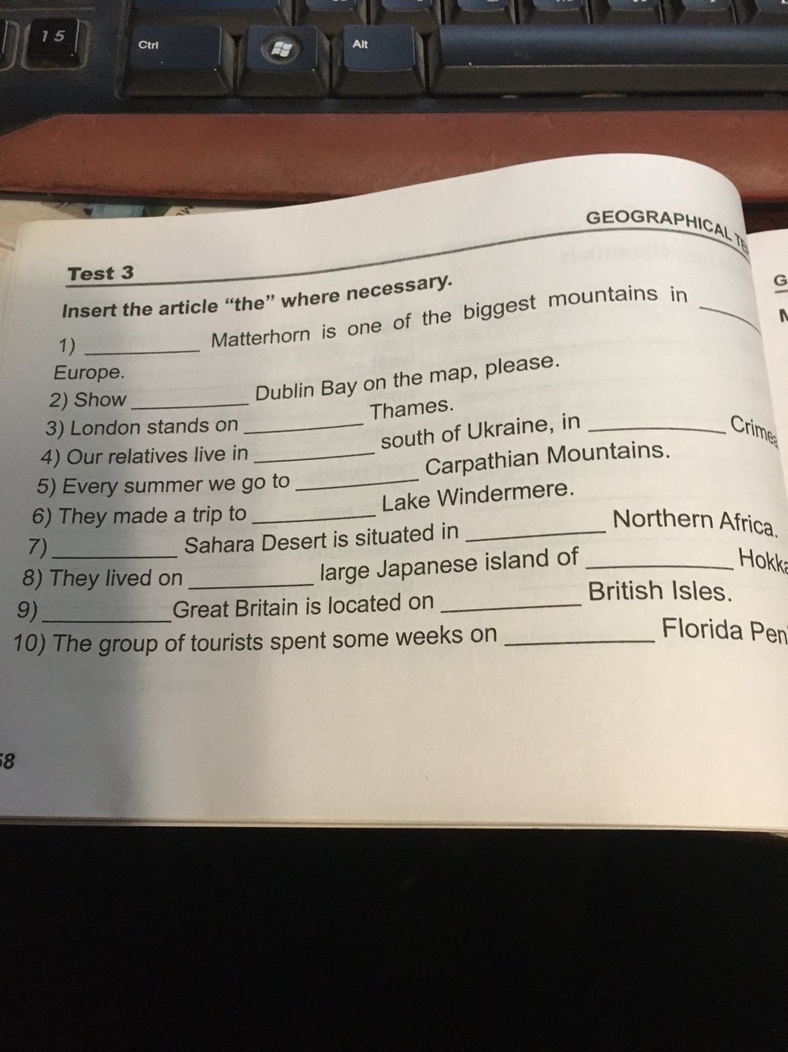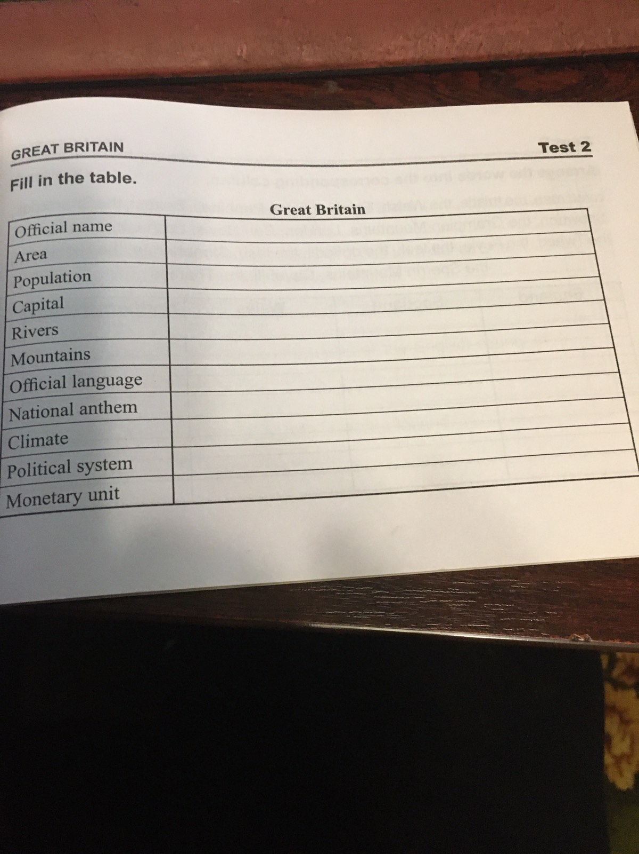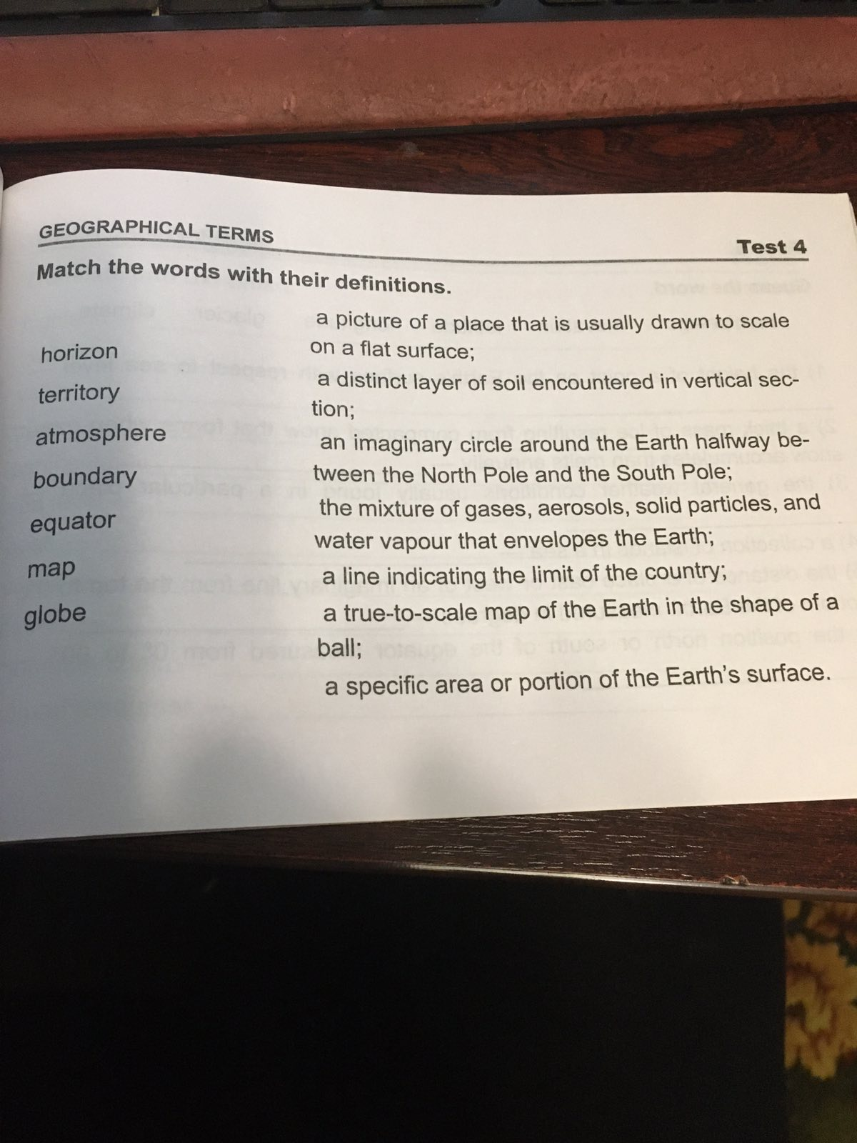

Mass media

There is a lot of information in our world. And there are many people who want to share this information. Mass media is the way how people share this information. There are a lot of kinds of mass media: internet, television, newspapers, magazines, books etc.
I want tell you about the greatest source of mass media. It is internet. I think that this is really the greatest thing that people have ever created. There are thousands of sites where people can find useful information. But we use it not only for information.
We can find a lot of friends there. We can communicate with them. We can make calls with help of internet. But from another point of view it is rather dangerous. There are many spies and viruses there. So they can damage your computer or steal the information from it.
Television is a great source of information. The first movie was made by Lumiere brothers in 1896. Television appeared later but after the World War II it became very popular and nowadays, I think, you won't find people who don't know what TV is. You will find TV sets almost in every house. Television is a source of information and entertainment. People watch TV to find the answers or just to relax. Many things are broadcasted on TV. You may watch the news or a good film. Using a satellite aerial you can join a lot of channels. You can learn foreign languages, because the channels are in different languages. You can find everything you want. There are special channels for children and adult, music and news channels. As it was counted an average person watches TV 3-7 hours a day. It varies in different countries, but you can see how popular television is.
Newspapers are rather spread in Ukraine too. There are a lot of kinds of newspapers and magazines. You can find a lot of useful information there too. We can also find a lot of interesting information using our mobile phone.
So, nowadays, mass media is very popular among people.
Variant I
I Mark the sentences True (+) or False (-)
- There is a lot of information in our world.
- There are many people who want to share this information.
- Mass media is the way how people share this information.
- The greatest source of mass media is internet.
- There are hundreds of sites where people can find useful information.
- We use Internet for information.
- We can find friends online.
- I think that this is really a dangerous thing that people created.
- It is safe online.
- Viruses can damage your computer.
- Television is not popular nowadays.
- The first movie was made by Lumiere brothers in 1898.

II Match the sentences
- After the World War II television …  - I think, you won't find people ..  - You will find TV sets …  - Television is a source of information …  - People watch TV to find …  - Many things are …  - You may watch the news …  - Using a satellite aerial you can join …  - You can learn foreign languages, because …  - You can find everything …  - There are special channels for children …  - As it was counted an average person watches …  - Newspapers are rather … | - almost in every house.  - became very popular.  - the answers or just to relax.  - or a good film.  - the channels are in different languages.  - you want.  - and adult, music and news channels.  - who don't know what TV is.  - spread in Ukraine too.  - of newspapers and magazines.  - using our mobile phone.  - and entertainment.  - broadcasted on TV.  - a lot of channels.  - TV 3-7 hours a day.

Variant II
I Mark the sentences True (+) or False (-)
- Television became very popular after the World War II.
- I think, you may find people who don't know what TV is.
- You will find TV sets almost in every building.
- Television is a source of information and relaxation.
- Many things are broadcasted on TV.
- You may watch the news or cartoons.
- Using a satellite aerial you can join a few channels.
- The channels are in different languages.
- There are special channels for children and adult.
- An average person watches TV 5-7 hours a day.
- Newspapers are rather spread in Ukraine too.
- Nowadays, mass media is very popular among people.

II Match the sentences
- There is a lot of information in …  - And there are many people …  - Mass media is the way how …  - There are a lot of kinds of mass media: …  - I want tell you about the greatest …  - I think that this is really the greatest thing …  - There are thousands of sites where people …  - But we use Internet not only …  - We can find a lot of …  - We can make calls with …  - But from another point of view it …  - There are many spies …  - Television is a great … | - internet, television, newspapers, magazines, books etc.  - that people have ever created.  - or steal the information from it.  - for information.  - help of internet.  - source of information.  - our world.  - people share this information.  - by Lumiere brothers in 1896.  - who want to share this information.  - source of mass media.  - can find useful information.  - friends there.  - and viruses in Internet.  - is rather dangerous.

Writing comprehension
- Use Possessive case. Перефразуйте, використовуючи присвійний відмінок іменника.
The flat of my sister, the son of her mother, the name of this man, the mark of our student , the balls of children, the parents of that boy , the hobby of these gentlemen , the food of those dogs , the parents of that boy .
- Use definite article “the” with geographical names.
- What's___________ longest river in ________ world? Is it______ Amazon or ______. Nile? I'm terrible at ____________ Geography.
- What's___________ longest river in ________ world? Is it______ Amazon or ______. Nile? I'm terrible at ____________ Geography.
- Burt loves islands.
He has been to _________ Cuba,_________ Bali, _________ Bahamas, _____ Philippines. And ______ next year, he wants to go to __________ Madagascar.
- __ British Prime Minister lives in _______ Downing Street 10 and goes to work by______car.
- The capital of ____ Australia is____ Canberra.
- The capital of ____Australia is ______Canberra.
- ____ Africa is much larger than ______ Europe.
- ____Hoverla is the highest peak.
- ___ River Thames is in ___ United Kingdom.
- Smiths prefer to spend the winter holidays in ____ Himalayas
- Use reflexive pronounse (myself, yourself, herself, himself, ourselves, themselves, yourselves).
- I wrote this poem____ .
- He cut ____ with a knife while he was doing the dishes.
- My mother often talks to ___ .
- Alice and Doris collected the stickers ____ .
- Bob made this bike _____ .
- We had to explain _____ to the teacher.
- I cleaned the house______.
- Alice saw in the mirror_____ .
- Tina and Bob are very organised. They planned their hoidays ____.
- Imagine your travel to the UK. Describe it.What places of interest would you like to visit?

Test Paper
- Matching:
- patron a) buildings
- an open-air b) sightseeing
- a trading c) activities
- golden d) tour
- go e) square
- leisure f) saint
- a guided g) attractions
- a fountain-filled h) museum
- tourist i) domes
- high-rise j) centre

- Filling in the gaps:
- famous b) named c) main d) worth e) caves f) buried g) meeting h) hill i) sightseeing j) known
- The most popular places for ______ in Kyiv are churches and cathedrals.
- This art gallery is really ______ visiting.
- What is the ______ street in Kyiv?
- The most popular ______ place is Maydan Nezalezhnosti.
- Standing on the _____ of the square you can see the domes of the church.
- This place is ______ as the centre of learning and culture.
- A lot of famous Ukrainians are _____ here.
- Firstly, I`d like to explore the _____ of this building.
- Who was this cathedral ______ after?
- What is this place ______ for?
III. Unscramble the dialogue:
1. a) To Britain? Great! When are you going there?
b) OK. You are a real friend.
c) No, I’m going to make a film. It will be my first experience.
d) It’s “Touring Guide to Britain”.
e) You are lucky! It’s my dream to visit London one day. Will you take pictures?
f) Hello, David. What are you reading?
g) Don’t worry! Everything will be OK. Last summer I filmed our trip to Kyiv. I can show and explain how to make it better.
h) My parents and I are going to London in July.
1…. 2…. 3…. 4…. 5…. 6…. 7…. 8….
- Grammar
Put the verbs into Past Simple or Past Perfect Tense:
- By the time the firefighters ____________________(arrive) the building __________________(already / burn) down.
- They _____________________ (go) to the cinema after they _____________________ (finish) their dinner.
- After he _____________________ (work) for the software company for two years he _____________________ (decide) to give it up.
- We _____________________ (live) in Italy before we _____________________ (move) to Spain.
- By the time the meeting _____________________(finish), they _____________________ (leave) the room.

Reading:
Text A
THE THEATRE
Britain has a long tradition of drama. British theatre began in the thirteenth century, before the time of Shakespeare, with a series of short stories from the Bible called the Mystery plays. Even today, every four years in York and Chester, ordinary people still perform these plays.
Acting, both by amateurs and professionals, is still very much alive in Britain. British professional actors are usually highly respected and well-trained. The most famous British theatres are the National theatre and Barbican. The Royal Shakespeare Company performs at the Barbican in London and in Stratford-on- Avon, where Shakespeare was born. These theatres receive money from the government so that they can perform several different plays a year. In spite of this money from the government, many theatres, including the National theatre and the Barbican, find it difficult to survive. There are many smaller theatre groups in Britain. Some of them receive money from the government to perform plays which are contemporary and experimental.
Commercial theatres do not receive any money from the government. They usually perform very popular plays. If a play is successful, the company will perform it for many years.
Say if the following statements true or false.
1. Three types of theatres are mentioned in the text. ____
2. Shakespeare was the person who started the tradition to stage the plays in the theatre. ____
3. Ordinary people in some cities prefer only watching plays not acting. ____
4. British professional actors usually show excellent acting. ____
5. All theatres in Britain receive money from the government. ____
6. All theatres stage only classical plays. _____
7. Shakespeare’s plays are staged only in his native town. ____
8. All theatres have a successful run. ____
9. Commercial theatres stage any plays they wish because they aren’t given any money from the government. ____

Text B

I. Check your understanding: true or false
1. Jennifer is American. ______
2. Jennifer was born in July. ______
3. She has two brothers. _____
4. Jennifer took acting classes at school. _______
5. Jennifer has done some modelling. ______
6. Jennifer was nominated for an Oscar in 2010. _____
7. She likes playing the piano. ______
8. Jennifer's family supported her dreams to be an actress. ______

- Answer the questions (give full answers):
- What sports did Jennifer play at school?_______________________________________
2. What films has Jennifer Lawrence starred in? ___________________________________
3. What cities has she lived in? ___________________________________________________
4. What jobs has she done? ________________________________________________________
5. What does Jennifer do in her free time? ____________________________________________
6. What are her two brothers called?_________________________________________________

Listening:
- Ordering : Do this exercise while you listen. Write a number (1-8) to put these places in order that the tour bus will visit them.
_____ Oxford Street
_____ Madame Tussauds, Museum
_____Tower of London
_____ London Eye
_____ Houses of Parliament
_____ Buckingham Palace
_____ Big Ben
_____ Tower Bridge

- Check your understanding: multiple choice
Circle the best word to complete these sentences.
1. The tour takes 2 / 3 / 4 hours.
2. At Madame Tussaud’s you can see maps of London / models of famous people / famous shops.
3. Oxford Street is a famous street for drinking tea / eating / shopping.
4. The Queen lives at Buckingham Palace / the Tower of London / Tower Bridge .
5. Big Ben is a tour guide / clock / bridge .
6. You can see great views of London from Oxford Street / the Houses of Parliament / London Eye.

FORM 8 VOCABULARY AND GRAMMAR TEST (UKRAINE/GREAT BRITAIN)
I. Make the word-combinations from the words below and translate them into Ukrainian:
1. natural a) space 4. outer d) climate
2. mild b)centre 5.administrative e) resources
3. scientific c) conditions 6. mineral f) research
II. Each sentence has a mistake. Correct the false sentences:
1. Ukraine borders on the Poland in the east.
2. The highest mountain of Great Britain is Snowdon.
3. Ukraine is one of the largest countries in the world.
4. The climate in Great Britain is moderate and continental.
5. Great Britain consists of four parts: England, Scotland, Wales and Ireland.
6. The United Kingdom is an island country that’s why it doesn’t border on any European country.
7. London is one of the youngest cities in the world that’s why it has no historical places.
8. Kyiv stands on both hills of the river Dniester.
III. Answer the questions:
1. What is the geographical position of Ukraine in the map of Europe?
2. Why are Ukrainian people proud of their capital?
3. What do you know about the historical regions of the United Kingdom of Great Britain and Northern Ireland?
4. What sights of Britain are the most attractive in your opinion?
_____________________________________________________________________________________
