Англійська мова 6 клас з 05.05.по 29.05.20
05.05=Англомовні країни.
Читати текст ст.187-188,письмово-впр.4-5,ст.189
Д\З- роб.зош ст60-61.
06.05-Навколо світу. Контроль навчальних досягнень.Завд роб зош-ст.62-64.
07.05-Контрольна робота з говоріння .
Вивчити текст про Україну або Англію.Впр.11,ст.185-186 по 3 речення з кожної таблиці.
12.05-Мій вивчений щоденник, написати .
13.05-14.05- Завдання по темі(додатково).
19.05-Контрольна робота з письма.
20.05-Контрольна робота з аудіювання .
21.05-Контрольна роботаз читання.
27.05-28.05-Семестрова контрольна робота.
29.05-Повторення вивченого матеріалу за рік.

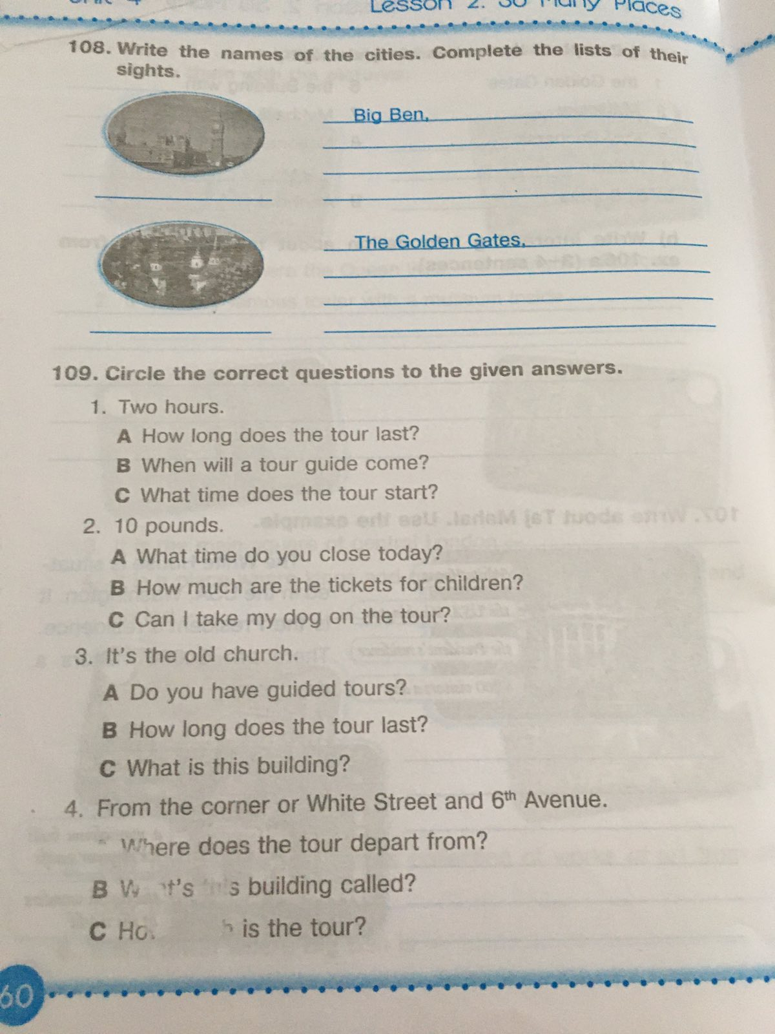
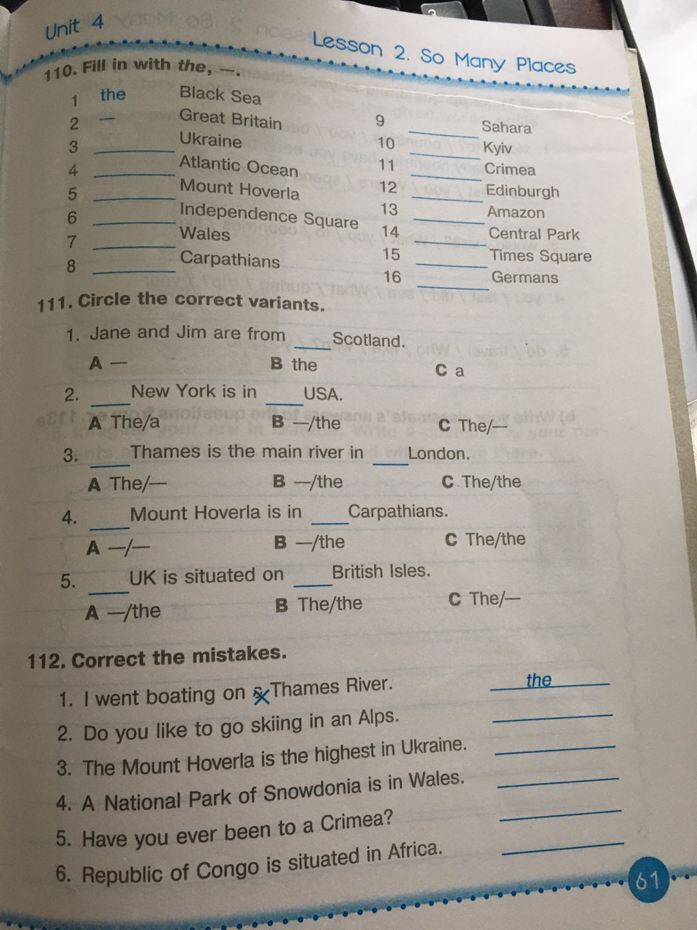
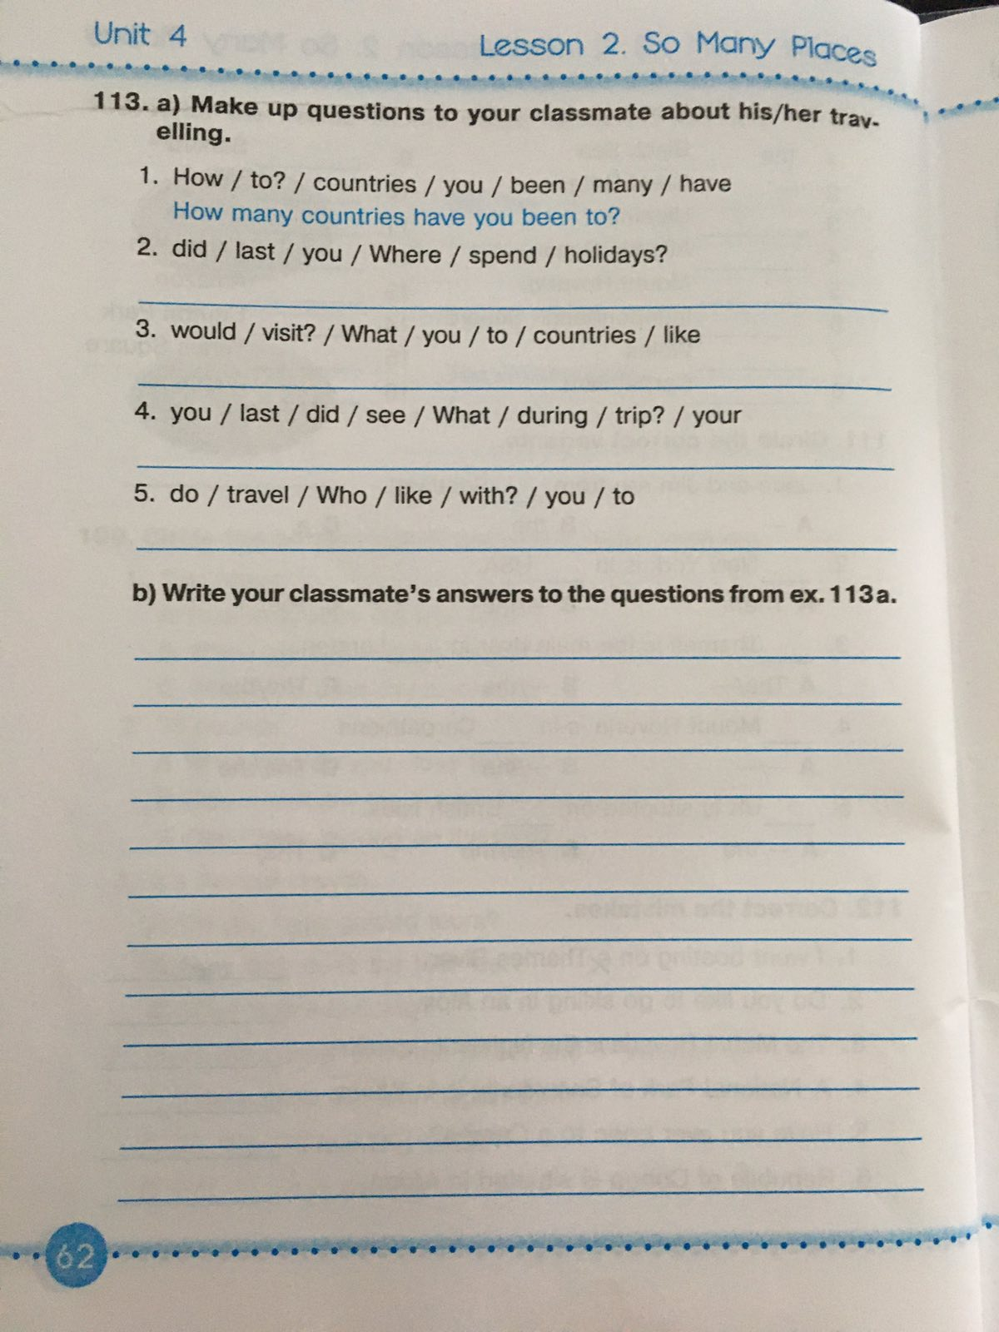
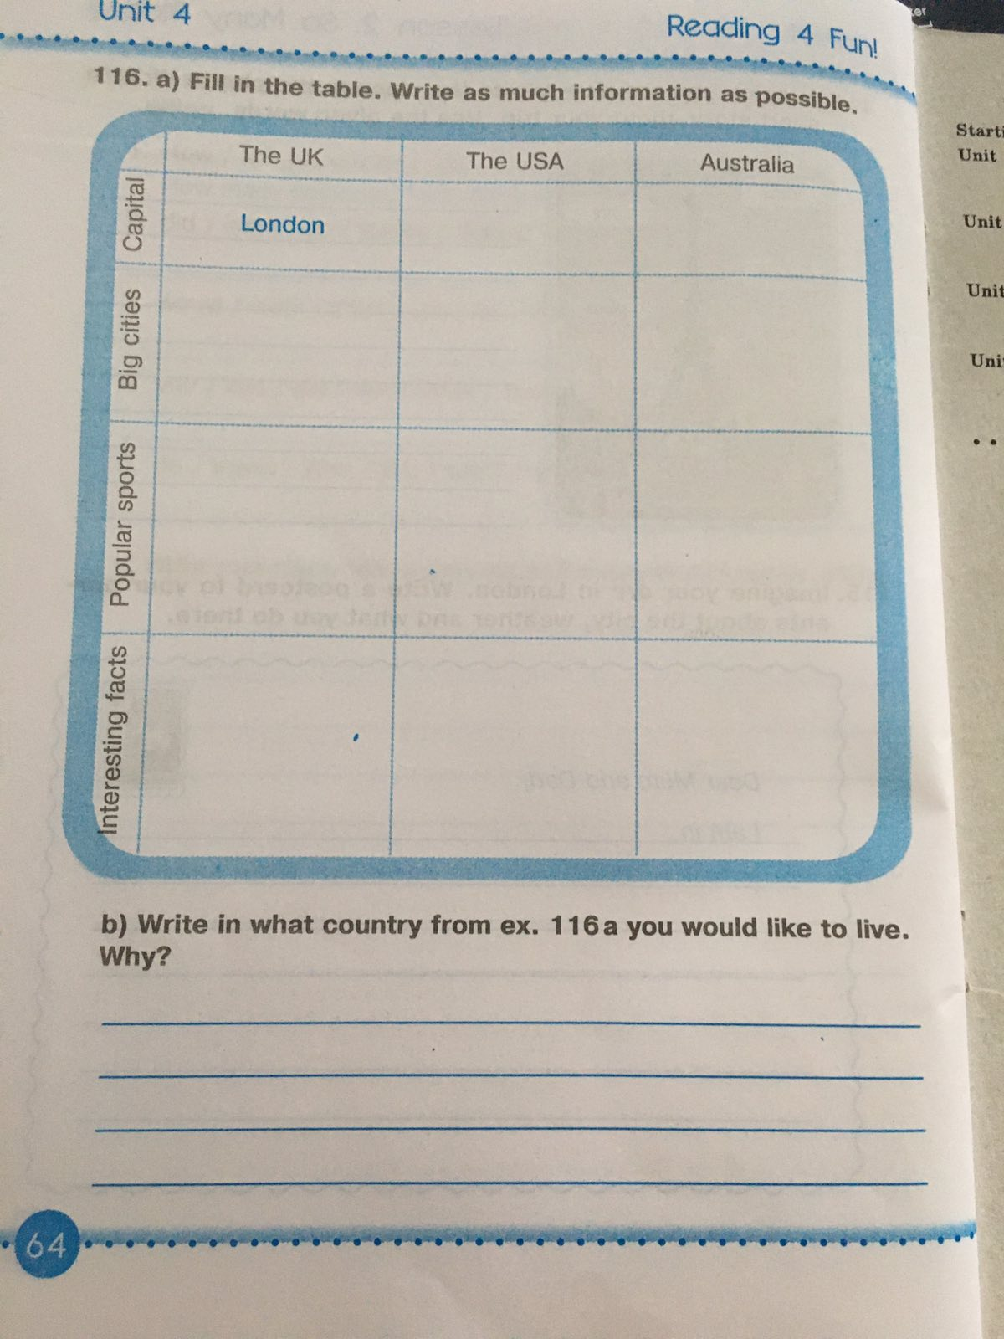

Test 6 form Kyiv
Task1 Match ( What to do…)
- Andriyivskyi Uzviz to see amazing frescoes and mosaics
- St.Sophiya Cathedral to visit mysterious caves
- Independence Square to buy national souvenirs, paintings
- Kyiv Pecherska Lavra to watch concerts, walk and have a rest
Task 2 Make up sentences
- So/crowded/Dower street/Andriyivskiy Uzviz/is/not/as.
- Is/so/as/St.Sophiya cathedral/not/popular/St.Andrew s church.
- London/as/is/beautiful/Kyiv/as.
- Kontraktova Square/as/is/Independence Square/not/big/as.
Task3 Write names of the most famous sights of Kyiv
1.______________ is a majestic place where official government ceremonies take place, it is surrounded by a green park with a panorama of the Dnipro.
2. ____________ is a main street of Kyiv, which becomes a pedestrian mall at the weekends.
3. ____________ is an ancient Monastery where you can see the caves where monks lived in ancient times.

V-1 Task 1 Match
- To look a journey
- To read in the dining-car
- To have lunch through the window
- To make a guidebook
Task 2 Put the word into the correct form
1.My cousins …( to make) a wonderful journey last summer.
2.She usually …(travel) with a small suitcase.
3. My brother …(to book) tickets at the moment.
4. The plan… just ( to land) at the airport.
Task 3. Circle the correct item
1.People often travel by (train/foot).
2. I prefer to travel by plane on (business/pleasure).
3.Many years ago travelling by ship was (comfortable/dangerous).
4.There is (too/to) ( much/many) noise at the airport.
Task 4 Write a composition
V-1 Task 1 Match
- To buy a ticket a journey
- To read in the ticket-machine
- To travel with friends
- To make a sign
Task 2 Put the word into the correct form
1.The train …just (to arrive)
2.They always…(to take) a lot of photos during their vacation.
3.We …(no to ntravel) last summer.
4.I …(to buy) tickets at the railway station at the moment.
Task 3. Circle the correct item
1.There are (to/too) (many/much) people at the railway station.
2.He often goes by train for ( pleasure/business)
3.I prefer to travel (on/by) fooy in summer.
4. Many years ago travelling by ship was not (expensive/comfortable).
Task 4 Write a composition

Writing comprehension
I. Make up questions.
1)places/recently/you/in/what/have/Ukraine/visited?
2)go/did/there/when/you?
3)of/you/means/by/travel/what/did/transport?
4)did/see/sights/you/there/what?
5)your/did/journey/like/you?
II. Put “the” where necessary.
1)____ British keep their traditions very carefully.
2)_____ Egypt is famous for ____ Pyramids.
3)When they visited _____ Scotland they stayed at ____ McCones’ house.
4)____ Viennain ____ United Kingdom or in ____ Austria?
5)Would you like to visit ____ Eiffel Tower or ____ Acropolis?
6)_____ Jacksons live in ____ Hill Street.
III. Put the verbs in brackets into the correct tense.
1)He promises that he ______ (to buy)the tickets for the concert tomorrow.
2)My parents always ______ (to stay)at this hotel.
3)I ____ never _____ (to be)to Berlin.
4)Look! They _______ (to get)off a train.
5)Last spring Frank______ (to take) many wonderful photos of animals in Africa.
6)My aunt _____ (to take) me to Mexico next summer.
IV. Complete the sentences with the prepositions from the box.
in into off with by on
1)What means of transport do you prefer to travel ____ ? – I prefer to travel ____ foot. 2)Will your daughter come to our village ____ autumn? 3)I enjoy spending my time ____ with my family.4)Kate got ____ the train and went along the road. 5)The bus arrived _____ Milan early in the morning. 6)Tom prefers playing _____ his friends. 7)My brother travels ___ business.

