Англійська мова 5 клас з 04.05 по 28.05.20
04.05-06.05.20.Їжа. Овочі та фрукти.
Впр.1а, ст 52(виписати слова в словник,вивчити).
Впр 1в,ст52 письмово,Впр.2- письмово(написати 5 речень)
Впр 3,ст53 читати,Впр.4(письмово).Вживання much,many,lots of, a lot of
Д\з Впр 4,ст.56 письмово
07.05.Дії на кухні.
Впр 1-ст.57 слова у словник, Впр 2,ст 57- письмово,Впр.3 ,ст57-58(читати)+тести Впр 4
Д\з Впр 6-7,ст 59 написати твір, що любите готувати на особливий день .
13.05-14.05-Харчування в школі.
Читати текст впр.1-а-ст.59+виконати тести 1в ст.60.
Д/З скласти меню як на ст.60.
18.05-Моє улюблене блюдо.
Читати впр 1,3,5,ст. 62-64.
Д/З написати рецепт страви(на власний вибір),див.завд.впр.5,ст.64
20.05-Їжа в Англії.
Впр .1-2,ст.65 (письмово)
21.05-Контрольна робота з аудіювання.
25.05-Контрольна робота з читання .
27.05-Контрольна робота з письма .
28.05-Контрольна робота з говоріння.
Це правило та тести виконуєте 5 завдань.

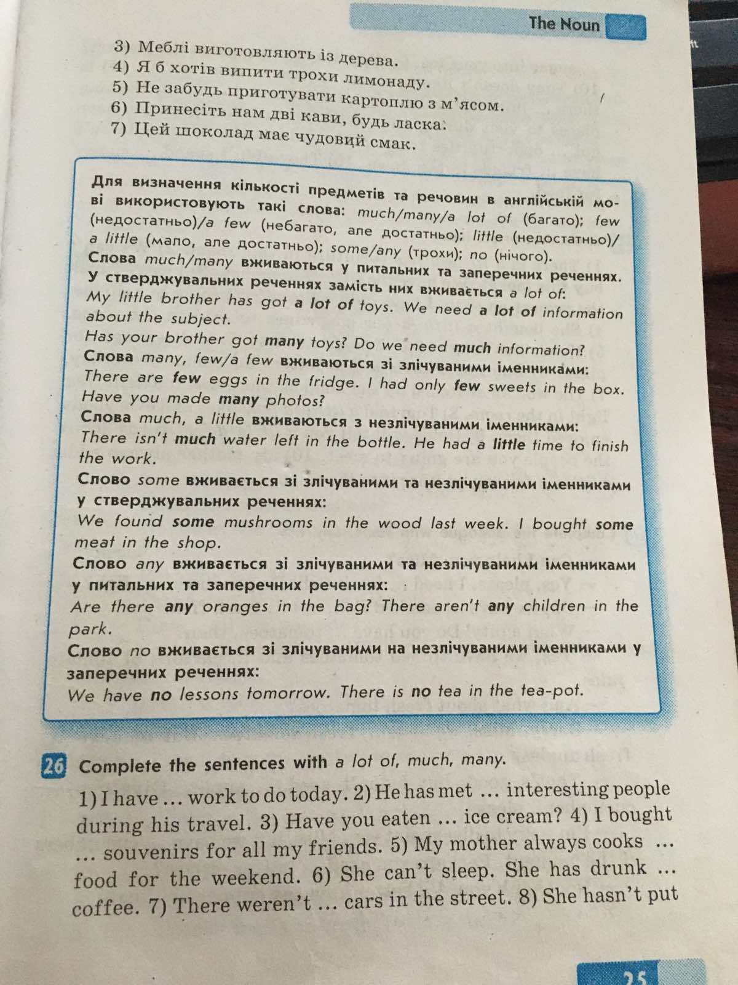

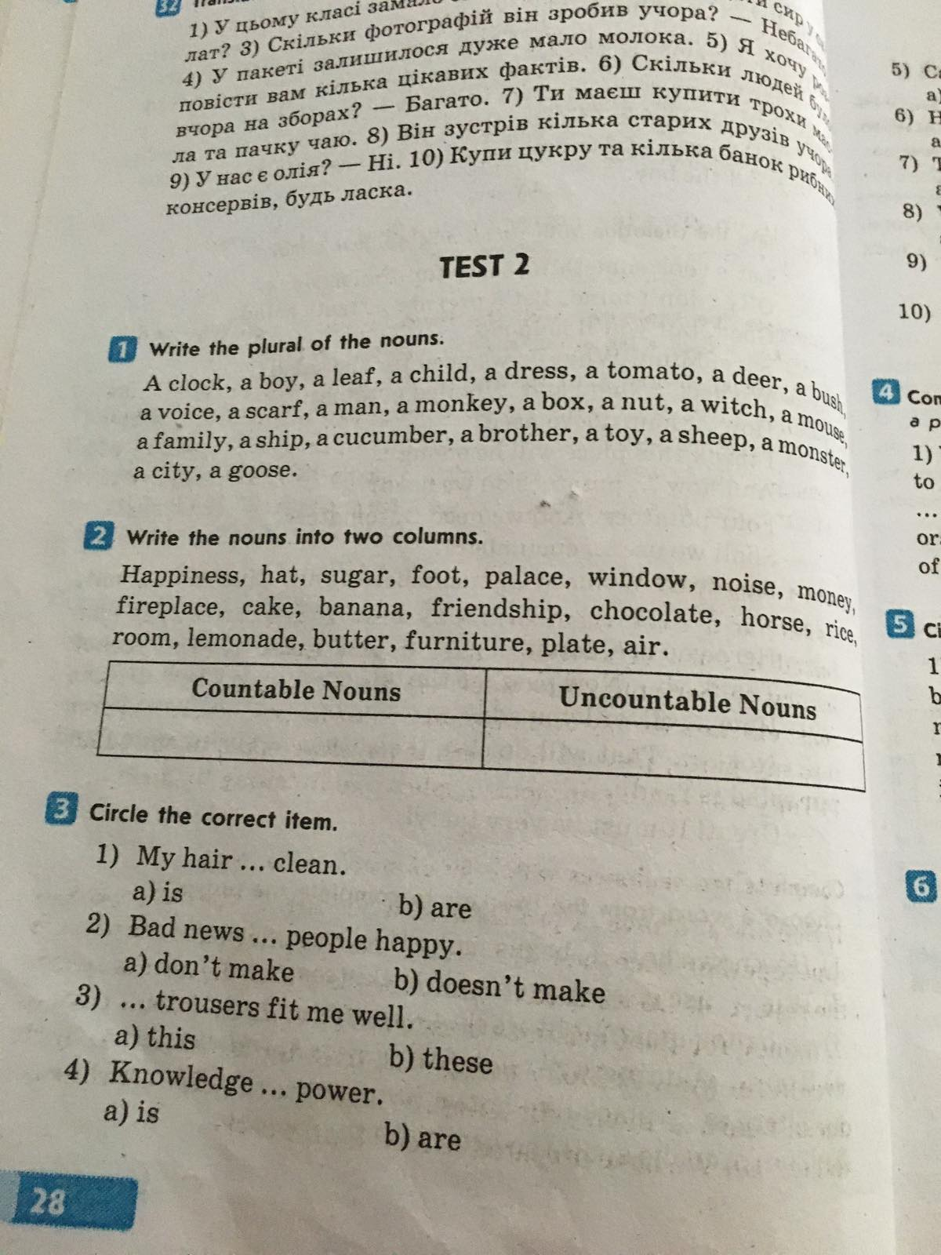
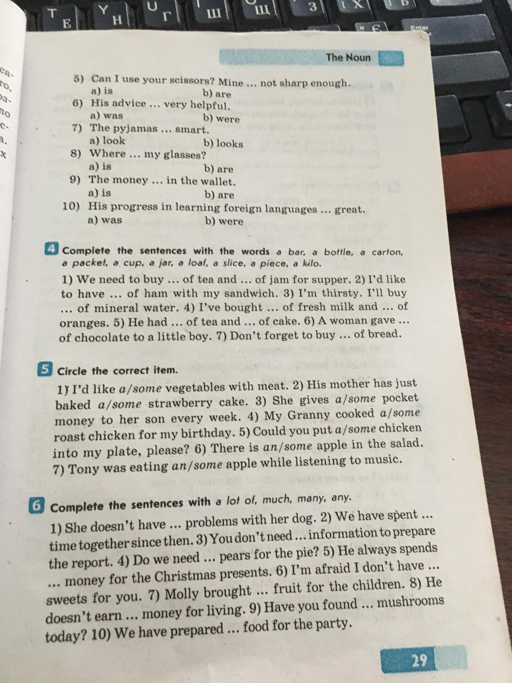

5 клаc ІІ семестр
WRITING
Variant - I
I. Read and match greetings with the proper season.
Spring Summer Autumn Winter
1.Merry Christmas and a Happy New Year!
2.Christ has Risen! – Indeed He has Risen!
3.Trick or treat!
4.Happy Mother’s Day!
5.Will you be my Valentine? Happy Valentine’s Day!
II. Write sentences. Use the Present Continuous.
Ex.: they /eat / breakfast
They are eating breakfast.
1. she / make / a sandwich
2. they / play / basketball
3. he / swim / in the swimming pool
4. she / listen / to music
5. they / run / on the stadium
6. I / have / a birthday party

III. Complete the sentences with the Present Continuous forms of the verbs.
1. Kim _______ (not watch) a film. She’s reading a book.
2. John isn’t drinking fruit juice. He ________ (drink) cola.
3. They’re cycling to school. They _______ (not walk).
IV. Complete the sentences with There is or There are.
1._________ some oranges on the table. 2.__________ some coffee in the cup. 3.__________ some bread. 4._________ five cups of coffee on the table. 5. _________ some crisps on the shelf.

V. Complete the sentences with some or any ?
1. Is there _______ milk in the fridge? 2. We’ve got _______ eggs. 3. There isn’t ______ sugar in my coffee.
4. We haven’t got _______ bananas. 5. There’s ________ fruit juice on the shelf.

VI. Complete the questions with How many or How much.
1. _________ brothers and sisters have you got? 2. _________ butter is left? 3.__________ apples can you eat?

VII. *Write what clothes do you usually/often/sometimes/never wear? What are your favourite clothes?
*Describe your favourite season.

Test-revision 5 form

- Write negative and interrogative sentences.

1. He writes a dictation sometimes.
2. I am listening to music now.
3. You cleaned the classroom yesterday.

- Ask questions.

1. She is playing in the park now. ( Who, Where)
2. They went to the shop yesterday. (Did, Who)
3. We swim in the sea every summer. ( Why, How)

- Make the plurals of the nouns.

A pen- a door- a man-
A class- a boy- a child-
A cat- a lady- a woman-
A bush- a house-

Test. Clothes we wear V-1
  - Match
Fasten Unlace
Lace up Loose
Zip Unfasten
Tight Unzip

  - Choose the correct answer
- Dennis seems to….. the same clothe every day- a red pullover with black jeans
    - Fit b) tight c) wear d) unlace
- A(an) … is a type of a headwear
  - Jeans b) hat c) anorak d) sweater
- Mike tried on a pair of jeans, but they were so … , he could hardly get the zip done up.
  - Tight b)loose c) fasten d 0 match
  - Answer the questions
    - What clothes do you wear at school?
    - Do you prefer loose jackets or tight jackets?
    - What clothes do you like to wear in summer?
    - What are you wearing at the moment?
  - Write a composition on the topic «Clothes we wear. My preferences»

